

3P RainForce
TH & TS Series Control Panel

Installation and Operation Manual

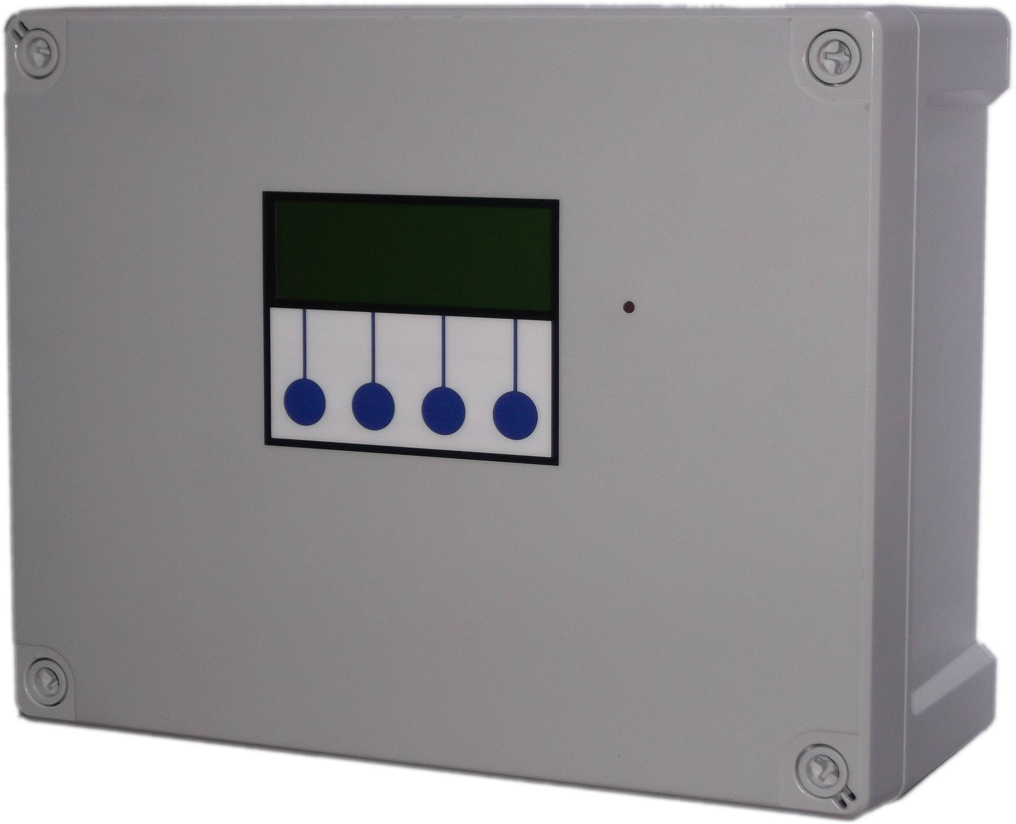

Installation

Safety
Mains Voltage – There are exposed electrical conductors inside this appliance. This appliance must be installed and serviced by a competent electrical technician to the current requirements of BS7671 and IEEE recommendations. Before servicing this appliance, normal safe isolation procedures should be implemented.

Do not touch the PCB while energised, it carries mains voltage.
Do not touch any connection terminals while energised.

Do not attempt to service this item when wet, or in a wet or high humidity environment.

If the housing of the control panel becomes damaged, you must shut down and securely isolate this appliance immediately.

You must connect this appliance to a grounded 3 wire supply, protected by suitable overload protection. Connected pumps and solenoids are earthed via the control panel, and may otherwise become live.

If the power cables are damaged, either to of from the controller then shut down and isolate this appliance.
Do not attempt to repair any part of the circuit board. Refer to the manufacturer for advice.

Included Components
1 x Control Panel

System Requirements for Installation
Self Contained Rainwater Harvesting Unit either cabinet built, skid mounted or similar, incorporating the following elements.

Single or twin pumps (single or 3 phase).

Common manifold for pump delivery line outlet with 4-20mA 0-10bar 2 wire pressure sensor installed suitable for 15vdc power source.

4-20mA 0-0.6bar 2-wire pressure sensor installed at the base of the main rainwater harvesting tank with vented cable from sensor to building envelope, suitable for 15vdc power source.

Break tank for mains water isolation with 230vac solenoid valve, and equipped with 4 x level switches (reed switches recommended, but can be any type that outputs a closed/open signal in the same manner as a switch.

Note that the break tank level switches must output open when water present and closed when water is not present. This is to ensure the break tank is read as full in the event of a cable disconnection to avoid the possibility of overflow due to a false empty tank reading.

Contactors & Thermal overloads are required for 3 phase pumps (1 contactor+overload per pump), note that the control panel itself requires a phase, and neutral at 230VAC, and an earth connection is required for all installations.

If operating in a hybrid configuration (mains and rainwater both filling the break tank) a supply pump in the rainwater tank.

If operating as a suction system, a 3 way motorised valve on the suction pump inlet manifold, to switch between rainwater supply (powered off), and mains water supply (powered on).

A solenoid valve or motorised valve, 230vac normally closed, mounted above the break tank and connected to the mains water supply, situated above the break tank to provide a type A-A air gap, or within the tank above an overflow slot to provide a Type A-B air gap.

3P Approved Parts are available from your distributor.

Layout
The recommended installation location of the control panel is within or mounted upon the rainwater control unit, although it's actual location could be anywhere within the building.
If the control panel is to be installed other than upon of within the rainwater control unit you will need to consider the following constraints,

The control panel cannot be mounted outside, it is not weather resistant.

Voltage drop will affect the cable size needed to take power to your pumps. Over very long runs, you may find it more economical to install contactors near to the pumps, allowing you to control the pumps with a sensible cable size. It is strongly recommended that you calculate voltage drop for cable runs which exceed the length of cable supplied with the pump. Failure to do so may result in cable overheating, conductor migration, and risk of fire. The same caution applies to solenoid valves, although the current draw is usually so small that only extreme distances are likely to present a problem.

Depending on model, you will have either a pressure transmitter, designed to provide exact water level information to the control panel, or a float switch, designed to sense the presence of water and indicate availability of rainwater or not. Cables extension is straightforward for both types of cable, and shielding is not required. Pressure transmitter cable must be of a special type incorporating a vent tube to equalise the pressure within the transmitter to atmospheric pressure (3P part no. IRVENT). Conductivity probe cable is 2 core 0.5mm2 unshielded.

For the extension of either type of cable we recommend an IP68 cable joiner 3P Part number X20BKSD.

Control Panel Mounting
Having selected a suitable location, unlock the 4 locking screws on the corners of the front cover and withdraw the front panel. The LCD display, buttons and alarm LED are connected to the PCB. Remove and replug these cables afterwards if necessary in accordance with the diagram.
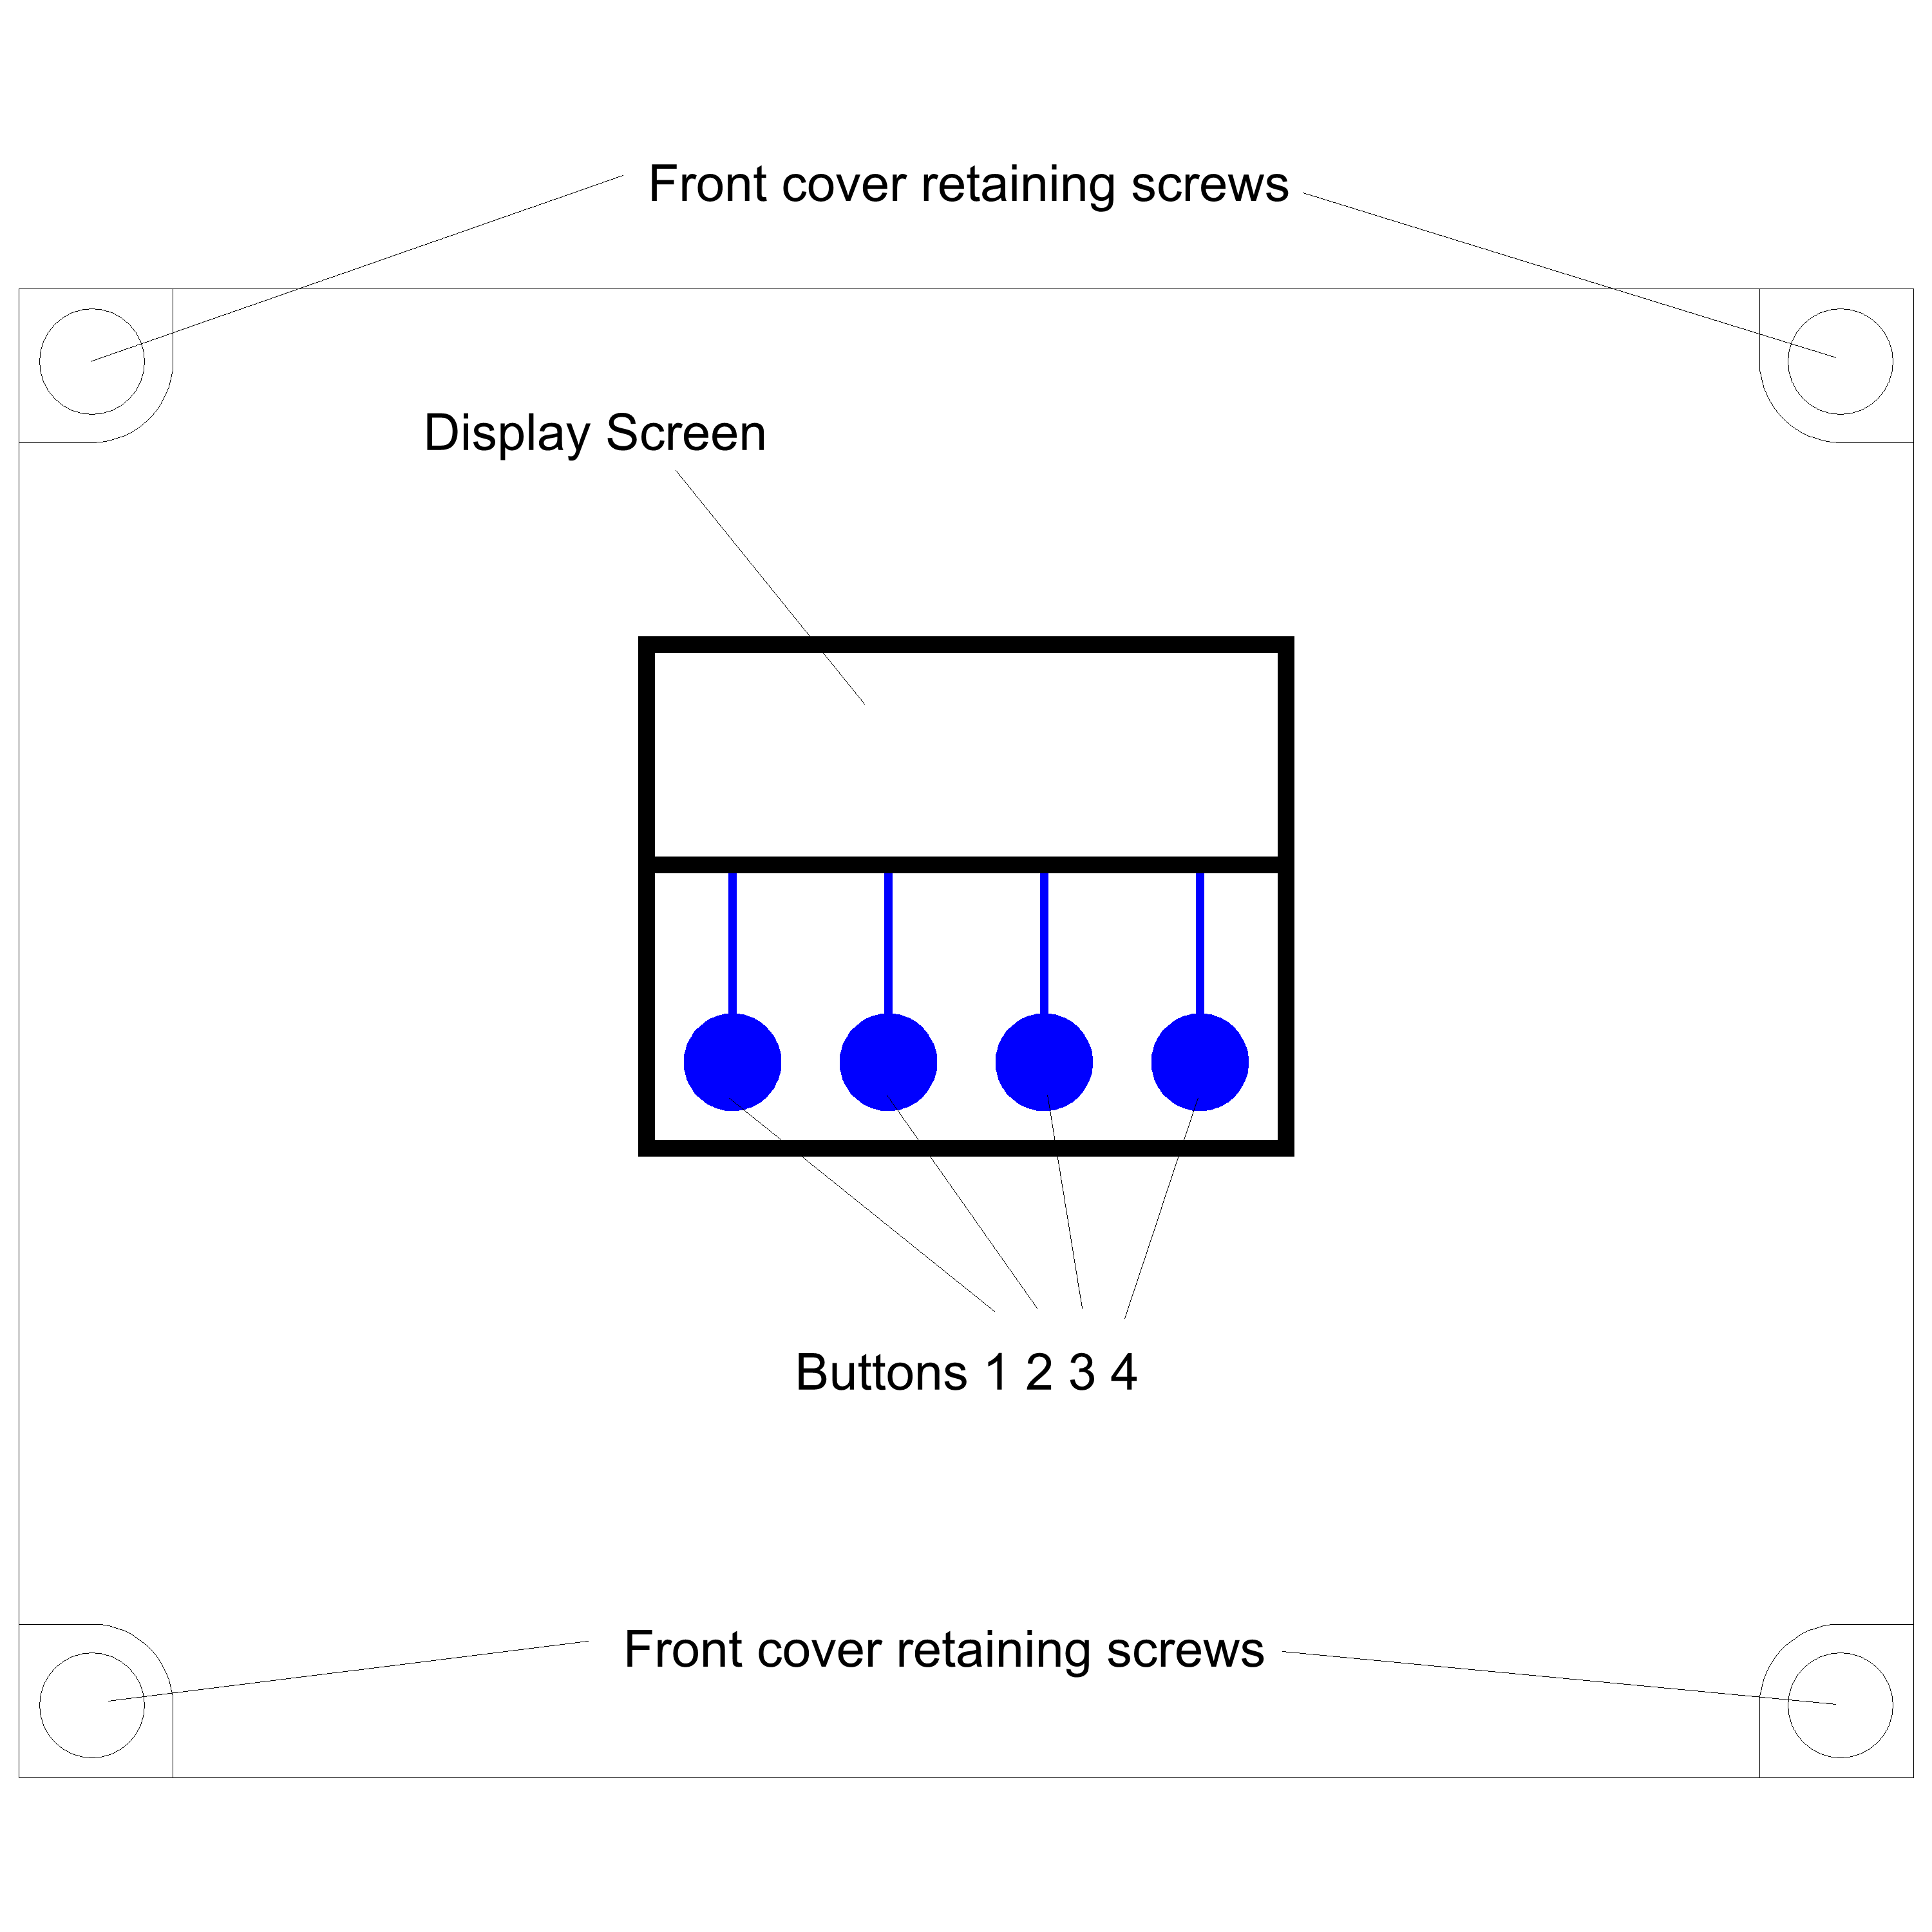

The 4 screw mounting holes are located on the main enclosure in recesses adjacent to the front panel mounting holes. Mark drilling points on the wall accordingly. Withdraw the casing from the wall and drill holes appropriate for your selected fixings.

Connections

Mains Power Connection
The power supply to the control panel enters via a cable gland on the bottom right of the housing. Insert the cable, connect to the incoming power terminal on the right of the PCB, and tighten the cable gland.

Pump Power Connections
Pumps are powered from the green terminals marked CON6 and CON6 on the lower right of the PCB. The terminal blocks are socketed and can be withdrawn from the PCB for ease of access. In a hybrid configuration (TH Series) an in-tank supply pump is connected to CON8.

Solenoid/Motorized Valve Power Connection
The solenoid (TH Series) or motorized valve (TS Series) is powered from terminal CON9. Connect as with pump connections.

Delivery line pressure sensor connection
Screw the pressure sensor into the port on the side of the T-piece attached to the pressure vessel. The pressure sensor connects with a 2 wire cable to connector CON4.

Terminals are
Left - +15v supply, connected to terminal 1 of the sensor
Right - 0v return (ground + signal return)

Rainwater tank sensor and connection
Connect the tank level sensor as follows

Pressure Transmitter (600TH & 600TS)

The pressure sensor connects with a 2 wire cable to connector CON3.
Terminals are

Left - +15v supply, connected to terminal 1 of the sensor
Right - 0v return (ground + signal return)

The pressure transmitter should be lowered onto the bottom of the rainwater tank and not suspended, and the vent sleeve or internal vent tube (depends on cable type) should be terminated to atmosphere in a dry location (not in the tank turret or underground supply duct).

Float Switch (500TH & 500TS)
Connect to pins 1 and 2 of CON11 (position 1 as markled under the socket, open circuit when hanging down, closed circuit when up (water present).

As the float switch cannot determine the exact water level, it must be attached within the tank to hang at the intended switching point. You should ensure this is at least several inches above the top of the pump to prevent pump damage during cold weather.

Break Tank Connections

These connect to CON11 as follows

Pins
Position as marked below socket
Switch Connected
Position on Break Tank
3 & 4
2
Low Level
Lowest
5 & 6
3
Mid Level
2nd lowest
7 & 8
4
High Level
2nd highest
9 & 10
5
Overflow
Highest

BMS connection
The BMS connection provides a non-voltage relay capable of switching any 230V source up to 10A. Three contacts are provided, Common, NO and NC. Connect your live conductor from the BMS system to Common, and output will be switched to NC in the absence of an alarm condition, switching to NO upon an alarm.

Pressure Vessel Installation
A pressure vessel must be installed. Compression of gas within the vessel provides a delayed accumulation and release of pressure, which this controller utilises in order to adjust the delivery line pressure using manual pumps, without the need for a variable frequency drive controller. It also substantially reduces power consumption, both by means of it's own storage capacity, and by allowing the controller to run the pumps within the most efficient part of their pressure curve.

Ideally this pressure vessel should be installed within or adjacent to the rainwater control unit. Do not install the pressure vessel inside the rainwater tank, or outside the building.

In order to achieve full efficiency, the precharge pressure within the vessel must be adjusted such that the vessel fills and empties within the cut-in and cut-out pressure required within the building. For most applications it should be set just below the pump cut-in pressure, for tall buildings, the pump cut-in pressure will often be higher than the default setting of 1.5bar.

Using the valve attached to the end of the vessel, attach a tyre pressure gauge, and release pressure until you achieve the right pressure as indicated below.

If the delivery line is empty (system can not yet been run), set the vessel to a pressure equal to or slightly above the intended cut-in pressure + expected static head.

If the delivery line contains water (system has been run), then there will most likely be a head of static water pressure in the delivery line above the vessel (0.1 bar for every metre or height).
The controller is not limited to working at this pressure and can still be adjusted, but will now be most efficient around this cut-in pressure.

Troubleshooting

Refer to the Safety instructions. No electrical works should be carried out other than by an appropriately qualified Electrician. Permits to work may be required at local site conditions. If in any doubt, consult your system supplier.

Problem
Probable Cause
Solutions
No Power – controller dead – no backlight on LCD
No power supply from distribution board

Fuse failed

PCB damaged
Check 240 vac 50hz supply at power input terminals.

Check Fuse F1

Replace PCB, contact manufacturer.
Backlight on – no display – no operation
CPU chip missing

CPU chip badly inserted or bent pins

CPU chip wrong way round

CPU chip faulty

PCB damaged
Insert CPU

Insert CPU correctly or replace if necessary

Remove and re-insert correctly
Replace CPU

Replace PCB, contact manufacturer.
Controller Frozen – operates normally but keypad unresponsive
Keypad not connected or connected wrongly
Check connection
Controller Frozen – does not operate normally
CPU or oscillator damaged
Replace CPU, if no success replace PCB
Float switch appears not to function (500TH/500TS)
Not connected

Cable damaged

Float not constrained properly

Float faulty
Check connection to control panel

Test continuity, replace if necessary

Tie float in tank such that it switches up/down around switch point

Replace
Tank level sensor does not function (600TH/600TS - error 6)
Not connected

Connected wrongly

Sensor faulty

Input circuit faulty
Check wiring to controller

Check wiring polarity and correct if needed

Test with current loop calibrator, replace sensor if necessary

Test with current loop calibrator, replace PCB if necessary
Tank Level sensor reads incorrectly (600TH/600TS)
Cable vent tube blocked or sealed

Wrong sensor specification installed

Sensor faulty
Ensure vented section of cable terminates to atmospheric pressure

Replace with original OEM spec part

Test with current loop calibrator, replace if necessary
Line pressure sensor does not function (error 7)
Not connected

Connected wrongly

Sensor faulty

Input circuit faulty
Check connection at control panel

Check wiring polarity and correct if necessary

Check with current loop calibrator and replace if necessary

Test with current loop calibrator, replace PCB if necessary
Line pressure sensor reads incorrectly
Wrong sensor specification installed

Sensor faulty

Input circuitry faulty
Replace with original OEM spec part

Test with current loop calibrator, replace sensor if necessary

Test with current loop calibrator, replace PCB if necessary
Pump 1 faulty
Pump not connected for over 10 seconds

Fuse failed on output

RCD/RCBO/Overload trip on output (if fitted)

Pump falls below low pressure alarm threshold for over 10 seconds

Pump faulty (most likely)
Check wiring

Check and replace if necessary

Insulation resistance test (megger) pump & supply cable

Replace with correctly sized pump or decrease pressure alarm setting

Replace pump
Pump 2 faulty
Pump not connected for over 10 seconds

Fuse failed on output

RCD/RCBO/Overload trip on output (if fitted)

Pump falls below low pressure alarm threshold for over 10 seconds

Pump faulty (most likely)
Check wiring

Check and replace if necessary

Insulation resistance test (megger) pump & supply cable

Replace with correctly sized pump or decrease pressure alarm setting

Replace pump
Solenoid Failure
Fuse failed on output

No water supply to solenoid

RCD/RCBO/Overload trip on output (if fitted)

Solenoid not connected

Solenoid faulty

Check fuse and replace if necessary

Check any supply valves supplying the system

Insulation resistance test (megger) pump & supply cable

Check wiring

Test and replace if necessary

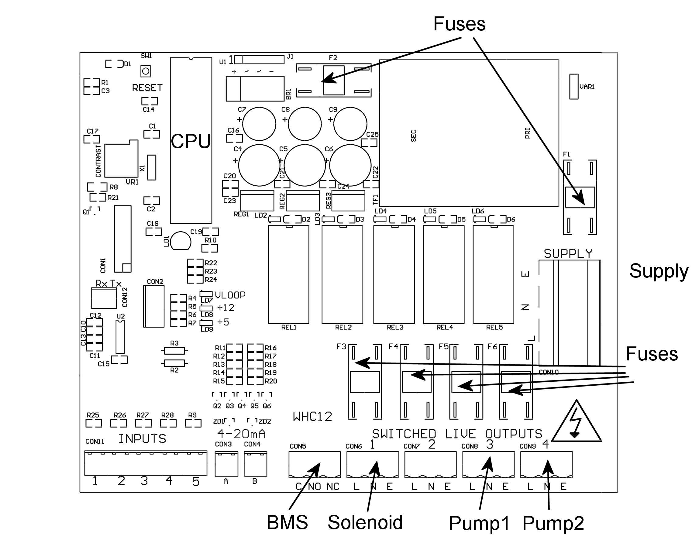

Fuse Listing
F1 – 500mA 20mm quickblow ceramic
F2 – 1A 20mm quickblow ceramic
F3 – 10A 20mm slowblow ceramic
F4 – 10A 20mm slowblow ceramic
F5 – 10A 20mm slowblow ceramic
F6 – 10A 20mm slowblow ceramic

Note – All fuses originally supplied in this control panel are ceramic high rupture current (HRC) fuses. Fuse F5 in particular supplies a pump outside of the building envelope and should only be replaced with a high rupture current fuse. This reduces potential damage to the control panel in the event of a nearby lightning strike.

Inputs (left to right) – Con1
1 – Rainwater tank float switch
2 – Break tank low level switch (lowest)
3 – Break tank mid level switch (lower mid)
4 – Break tank high level switch (upper mid)
5 – Break tank overflow warning switch (highest)

Pressure Sensor Inputs (left to right)
Con3 (left) – Rainwater tank level sensor (600TH/TS)
Con4 (right) – Line pressure sensor

BMS Output
Type – Non contact relay
Terminals – Common, Normally Open, Normally Closed
Power Rating max 10A 230Vac

Pump/Solenoid Control Outputs (left to right)
1 – Pump1 (Usually left pump in main pump set)
2 – Pump2 (Usually right pump in main pump set)
3 – Pump3 (In rainwater supply tank – 500TH/600TH) or Motorized valve (500TS/600TS)
4 – Solenoid (Above mains water break tank)

Specifications

Control Panel
Dimensions 240mm x 190mm x 110mm
Supply Voltage 230-240 Vac 50Hz
Power Consumption 7w
Operating temperature range 0 to 40 degrees celsius
Ingress protection IP66

Float Switch and Break Tank Inputs
Type Switch, closed or open
Float Switch Closed circuit when water detected, open circuit when tank empty
Break Tank Switches Open circuit when water detected, closed when tank empty

RW Tank Pressure Sensor Input (600TH/600TS)
Type Pressure Transmitter 2 wire
Measurement Range 0-0.6 bar
Input 8 to 30 Vdc
Output 4-20mA

Line Pressure Sensor Input
Type Pressure Transmitter 2 wire
Measurement Range 0-10 bar
Input 8 to 30 Vdc
Output 4-20mA

Switched Outputs (pump/solenoid control)
Voltage 230-240vac 50hz (exact voltage as supply voltage)
Current 10A (peak 16A)

Operation

Safety Considerations
Mains Voltage – There are exposed electrical conductors inside this appliance. This appliance must be installed and serviced by a competent electrical technician to the current requirements of BS7671 and IEEE recommendations. Before servicing this appliance, normal safe isolation procedures should be implemented.

Do not touch the PCB while energised, it carries mains voltage.
Do not touch any connection terminals while energised.

Do not attempt to service this item when wet, or in a wet or high humidity environment.

If the housing of the control panel becomes damaged, you must shut down and securely isolate this appliance immediately.

You must connect this appliance to a grounded 3 wire supply, protected by suitable overload protection. Connected pumps and solenoids are earthed via the control panel, and may otherwise become live.

If the power cables are damaged, either to or from the controller then shut down and isolate this apliance.
The combined loading of pumps and solenoids connected t this appliance must not exceed 20A using the supplied mains flex. Contact the manufacturer for advice if you need to exceed this rating.

Do not attempt to repair any part of the circuit board. Refer to the manufacturer for advice.

Description of Operation
The 3P RainForce TH and TS series control panels are an advanced rainwater management solution, designed to manage the supply of water from an underground rainwater harvesting tank to supply points within the building under direct pressure, with mains water back up supplied via an intermediate break tank. Like all Rainforce commercial controllers it has been designed to prioritise maximum availability of water (preferring rainwater where possible) with minimal power consumption, whilst keeping possible points of failure to a minimum.

This control panel may be installed within a 3P Technik commercial rainwater harvesting unit, but is also a compatible replacement or upgrade for several rainwater harvesting units manufactured by others.

Pump control is provided via direct mains voltage outputs from the control panel, operating as necessary to maintain an optimum pressure range (adjustable). Duty standby and duty assist are supported. Pumps may be run either in alternation, or with 1 active and 1 redundant spare. Faulty pumps are automatically retired.

There is no requirement for pumps to be matched, or for any specific model to be used in conjunction with this controller so long as they meet the minimum required pressure. Automatic pumps may also be used if the additional security of dry run protection is desired, although pump cut in/out function will be taken over by the RainForce controller.

Mains water backup is provided by a top-up solenoid, filling a break tank situated locally to the control system. The break tank is either used exclusively for mains water, with a motorized valve switching the pump inlet between rainwater supply and break tank supply, or it may be a combined mains and rainwater break tank, supplied with water both by a mains water solenoid and an in-tank supply pump within the main rainwater harvesting tank.

Control Panel Operations

Startup Screen Menus and Functions
Upon first applying power, the LCD panel will display a start-up logo followed by automatic calibration of the rainwater tank sensor (600TH/TS only) for approximately 3 seconds, and then immediately commence operation. The main screen displays the following information:

Rainwater Level Display in % (600TH/TS) or Rainwater tank status (500TH/TS)
Delivery Line Pressure (in bar)
Pump Status (on/off)

Rainwater Level Display (600TH/TS)
The current rainwater level will be shown in %, and is measured by a submerged pressure sensor at the bottom opf the rainwater tank. The scale is adjusted automatically as the control panel learns the maximum and minimum rainwater levels within the tank, with 0% being the minimum height of water detected during operation, and 100% being the highest water level detected. Initially therefore, the display will be inaccurate until the rainwater level changes. This does not affect other level related functions such as top-up level, etc.

Rainwater Tank Status (500TH/TS)
The current rainwater status is displayed either as OK or Empty.

Accessing the Menu Options
The last line of the display always shows up to four menu options, which can be selected by pressing one of the four corresponding buttons beneath the display. The menu options displayed will change as you enter different areas of the software.

Status Screen and Operational Modes

Menu Options, Button 1 - Configuration and Diagnostics

All other options relating to configuration and diagnostics, can be found via Button 1 from within the status screen. Whilst in this area all operation is halted while parameters are being set by the operator. To exit press “run”.

Rainwater Tank Menu (RW Tank Menu)
All options under this menu are related to operations within the rainwater tank.

Reset Rainwater % (Reset RW %) – 600TH/TS only
Selecting this option will cause the control panel to disregard previously learned water depths within the rainwater tank. The system will then re-learn the maximum and minimum water levels over time.

Minimum Rainwater Level Control (Min RW Lvl)
This setting allows you to change the level at which the rainwater tank is considered empty, and pumping will cease to prevent dry-running and preserve enough water to protect submerged pumps against frost. The default level is 60cm.

NOTE – it is essential that you allow sufficient depth of water above the pump to protect the pump from frost during the winter, we would suggest a minimum of 20cm above the top of the pump.

Pump Control (Pump Ctrl)
This is a sub-menu containing functions related to pump selection and pressure.

Pump Selection (Pumps)
Here you can select which pump you would like to use. The default setting is Pump 1. If your system has 1 pump only then you should leave it on this setting.

If you have a second pump fitted. You can choose to either leave it as a redundant spare, or to run in twin pump mode (duty assist with pump alternation).

In the event that a pump fails to produce sufficient pressure, a warning will be activated, and the pump abandoned. The system will now run in single pump mode using the remaining pump. The BMS will activate during pump failure, and will discontinue once a working pump has been found. In the event that a second pump is also faulty, or is not fitted, the system will cycle between pumps in attempt to restart an available pump which may have an intermittent fault, if no success the system will cease operation and report a critical fault. At this point the BMS alarm is continuously active, alerting the operator to this condition.

Pump Pressure Adjustment
The default setting is Pump1 cuts in at 1.5 bar and Pump2 cuts in at 2 bar, both pumps cut out at 3bar (also adjustable).

The pressure you select will of course depend on the height difference between the pressure sensor and point of use, and the required pressure. The pressure at the point of use will decrease by 1 bar per 10m of lift, and so this should be taken into account when setting the pump pressure.

It is advisable to set both pump to cut in at different pressures. Although the control panel will allow the same pressure to be set on both pumps, this would result in unnecessary use of both pumps, and delays the units diagnostic process, should a fault occur.

To attain maximum efficiency, you should select a pump set which can deliver the maximum required pressure within the efficient zone of it's performance curve (before the curve levels off). As centrifugal pumps are less efficient at their maximum rated pressure, and as we have full control of the cut-out pressure, it makes sense to select a pump on the premise that we will be using it with it's most efficient performance characteristics.

Alarm (Pump Pressure Alarm)

Here you can set the alarm pressure for the pumps. This consists of 2 settings, the minimum expected pressure during operation for either of the pumps (below which a pump will be considered inoperative), and the maximum pressure which must not be exceeded for the safety of the system.

The default setting for minimum pressure is 1 bar. In most circumstances this need not be adjusted, however is very large pipe diameters and discharge rates are used in relation to the pump flow rate then pressure in the system may reasonably be expected to fall below this level, hence the alarm pressure would need reducing. Similarly if the lift height above the pumps exceeds 10m, then there will always be more than 1 bar static pressure in the system even if the pumps have failed, therefore this setting would need to be increased by 1 bar per 10m. If pressure falls below this point for more than 10 seconds while pumping, a fault will be registered against the pump in operation and the system will failover to the next available pump.

The default setting for maximum pressure is 8 bar. This is the 'do not exceed' pressure of the discharge system and is necessary to protect pipework and fittings from failure due to an unexpected overpressure. It is set by default to match the rated pressure of typical MDPE pipe and fittings. You should adjust this to match the pressure of the lowest rated component in the discharge line if lower than 8 bar. UV systems and ballcocks often have significantly lower maximum rated pressures. An unexpected overpressure can occur when 2 pumps are connected in series (one after the other) by mistake, or after a loss of air pressure in the pressure vessel (if high pressure pumps are used). If the maximum set pressure is exceeded the system shuts down completely and does not restart until power is isolated and re-applied. This is to ensure intervention to rectify the fault.

Pump Restart Delay
This setting was introduced in version 1.20 to accommodate temporary sensor inaccuracies caused by incorrect top-up installation. In some installations, particularly where the mandatory tundish and air gap have been omitted, the flow of top up water into the tank may cause sufficient turbulence to affect sensor accuracy. This can result in the pump restarting and stopping rapidly as the sensor reading fluctuates around the pump cut-off level. This setting delays the restart of the pump until the required water level has been established for a set period of time.

During commissioning or at any point afterwards, if the pump is found to cut in and out rapidly during mains top-up or after a low level shut off, this setting should be increased until there is no more undue cycling of the pump.

Diagnostics Menu
Once selected via Button 3, here are three buttons or menu options available under the “Diagnostics” menu.

Input Monitor
Selecting this option shows the status of all sensor inputs to the controller. The following information is displayed.

Line 1, Switched inputs 1 to 5, whose assignment is as follows

1 – Float Switch (500TH/TS models only, unused on 600TH/TS)
2 – Break Tank Low Level
3 – Break Tank Mid Level
4 – Break Tank High Level
5 – Break Tank Overflow Warning

Line 2, Rainwater tank level sensor (600TH/TS only) shown in %
Line 3, Delivery line pressure

Output Testing
This option allows you to fire the 230v outputs of the controller.

Button 1 – Pump1
Button 2 – Pump2
Button 3 – Pump3 (In-tank)
Button 4 – Solenoid

Read Stored Fault Codes
This RainForce Controller is equipped with Advanced Fault Tracking, and will remember the last 10 faults that have occurred (even after power outage). This gives the Operator much greater insight into any fault should one occur as the fault history can be examined, and an informed judgement made.
Fault Code List

Code
Message
Description
3
Break Tank Low Level Switch
Operation Halted
The low level switch (lowest) in the break tank has activated out of sequence and is suspected to be faulty
4
Break Tank Mid Level Switch
Operation Halted
The mid level switch (2nd lowest) in the break tank has activated out of sequence and is suspected to be faulty
5
Break Tank High Level Switch
Operation Halted
The high level switch (2nd highest) in the break tank has activated out of sequence and is suspected to be faulty
6
Rainwater Tank Probe Failure
The rainwater tank level sensor has has been disconnected or has returned an implausible reading
7
Delivery Line Pressure Sensor
The pressure sensor on the delivery line has been disconnected of has returned an implausible reading
9
Solenoid Failure
The mains cold water top-up solenoid above the break tank has failed to fill the tank to the lowest sensor within 30 minutes
10
Break Tank
Overflow Detected
Operation Halted
The overflow warning switch (highest) in the break tank has activated and all operation has been halted to prevent a possible overflow of the break tank
11
Abandoning Pump 1
Pump 1 pressure could not reach the low pressure alarm threshold for a continuous 10 seconds. System operation automatically reverts to Pump 2 only
12
Abandoning Pump 2
Pump 2 pressure could not reach the low pressure alarm threshold for a continuous 10 seconds. System operation automatically reverts to Pump 1 only
13
Both Pumps faulty
Power off to reset
Both pumps have fallen below the low pressure alarm threshold for a continuous 10 seconds, several retries have been attempted and failed and the system has shut down to prevent damage
14
Line Pressure Too High
The pressure reported by the delivery line pressure sensor has exceeded the high pressure alarm threshold and the system has been shut down to prevent damage to connected pipework

The following menu Options now available are

Clear Stored Fault Codes
Selecting this option clears all stored fault codes from the controllers memory.
Run
Resume operation. Select this to return to the main operational display when configuration/diagnostic is finished.

Stop
At any time while the system is running (i.e. not in a menu setting), the operation of the panel, pumps and solenoid can be halted by pressing STOP. Unlike pressing Menu, this option will activate the BMS output to indicate that the unit has been halted for a purpose other than configuration. It is expected that this button may be used by persons with no knowledge of the system and/or no access to the Operation Manual. Under this setting there are 3 options.

Menu
Enters the main system menu, thus allowing faults to be inspected and cleared.

Wipe Configuration (Wipe Config)
This option wipes all configuration settings from memory then restarts the system. Default values will then be loaded and the system will behave as if it were switched on for the first time.

NOTE – Any options set during commissioning will be lost and need to be re-entered.

Restart
Restarts operation of the system. The BMS activation remains on until fault codes are cleared manually, although no fault code is stored for a manual stop condition as it is not considered a fault.

Troubleshooting
Refer to the Safety instructions. No electrical works should be carried out other than by an appropriately qualified Electrician. Permits to work may be required at local site conditions. If in any doubt, consult your system supplier.

Problem
Probable Cause
Solutions
No Power – controller dead – no backlight on LCD
No power supply from distribution board

Fuse failed

PCB damaged
Check 240 vac 50hz supply at power input terminals.

Check Fuse F1

Replace PCB, contact manufacturer.
Backlight on – no display – no operation
CPU chip missing

CPU chip badly inserted or bent pins

CPU chip wrong way round

CPU chip faulty

PCB damaged
Insert CPU

Insert CPU correctly or replace if necessary

Remove and re-insert correctly
Replace CPU

Replace PCB, contact manufacturer.
Controller Frozen – operates normally but keypad unresponsive
Keypad not connected or connected wrongly
Check connection
Controller Frozen – does not operate normally
CPU or oscillator damaged
Replace CPU, if no success replace PCB
Float switch appears not to function (500TH/500TS)
Not connected

Cable damaged

Float not constrained properly

Float faulty
Check connection to control panel

Test continuity, replace if necessary

Tie float in tank such that it switches up/down around switch point

Replace
Tank level sensor does not function (600TH/600TS - error 6)
Not connected

Connected wrongly

Sensor faulty

Input circuit faulty
Check wiring to controller

Check wiring polarity and correct if needed

Test with current loop calibrator, replace sensor if necessary

Test with current loop calibrator, replace PCB if necessary
Tank Level sensor reads incorrectly (600TH/600TS)
Cable vent tube blocked or sealed

Wrong sensor specification installed

Sensor faulty
Ensure vented section of cable terminates to atmospheric pressure

Replace with original OEM spec part

Test with current loop calibrator, replace if necessary
Line pressure sensor does not function (error 7)
Not connected

Connected wrongly

Sensor faulty

Input circuit faulty
Check connection at control panel

Check wiring polarity and correct if necessary

Check with current loop calibrator and replace if necessary

Test with current loop calibrator, replace PCB if necessary
Line pressure sensor reads incorrectly
Wrong sensor specification installed

Sensor faulty

Input circuitry faulty
Replace with original OEM spec part

Test with current loop calibrator, replace sensor if necessary

Test with current loop calibrator, replace PCB if necessary
Pump 1 faulty
Pump not connected for over 10 seconds

Fuse failed on output

RCD/RCBO/Overload trip on output (if fitted)

Pump falls below low pressure alarm threshold for over 10 seconds

Pump faulty (most likely)
Check wiring

Check and replace if necessary

Insulation resistance test (megger) pump & supply cable

Replace with correctly sized pump or decrease pressure alarm setting

Replace pump
Pump 2 faulty
Pump not connected for over 10 seconds

Fuse failed on output

RCD/RCBO/Overload trip on output (if fitted)

Pump falls below low pressure alarm threshold for over 10 seconds

Pump faulty (most likely)
Check wiring

Check and replace if necessary

Insulation resistance test (megger) pump & supply cable

Replace with correctly sized pump or decrease pressure alarm setting

Replace pump
Top-up Solenoid Faulty or Insufficient
Solenoid cannot keep up with demand

Fuse failed on output

RCD/RCBO/Overload trip on output (if fitted)

Solenoid not connected

Solenoid faulty

Replace with correctly sized solenoid

Check fuse and replace if necessary
Insulation resistance test (megger) pump & supply cable

Check wiring

Test and replace if necessary

Upgrades and Modifications

The following parts of the system can be upgraded at any time without any modification to the control panel.

Replacement/upgrade of pump(s)
Replacement/upgrade of solenoid(s)

Note – there is no need to reprogram or adjust the control panel settings when replacing a pump with one of a different power output or consumption. Diagnostic functions are not dependent on current monitoring.

Installation of 3 phase pump(s) via external contactor/relay.

Software upgrade by either on-site reprogramming, or by CPU replacement. Reprogramming is unlikely to ever be necessary, but is provided for to allow for custom software to be retrofitted to the control panel. It is carried out by an approved engineer via an on-board programming port, or via replacement of the CPU. The CPU is socketed in a 40pin DIP socket for ease of replacement.

When replacing the CPU, always use a proper Extraction Tool, and follow the instruction provided with the replacement CPU.

